MEDICAL INVENTORY MANAGEMENT

# TEAM ID :

# TEAM MEMBERS :

**Team Leader Name : S.NARMATHA**

**Email :** [**snarmatha737@gmail.com**](mailto:snarmatha737@gmail.com)

**Team member 1 : N.VASANTHASENA**

**Email :** [**vasanthasena367@gmail.com**](mailto:vasanthasena367@gmail.com)

**Team member 2 : R.SREEHA**

**Email :** [**sreehar70@gmail.com**](mailto:sreehar70@gmail.com)

**Team member 3 : S.SANGEETHA**

**Email :** [**sangee908050@gmail.com**](mailto:sangee908050@gmail.com)

# 1.INTRODUCTION

## 1.1 Project Overview

The **Medical Inventory Management System** is a Salesforce-based application designed to streamline and manage various operational aspects of medical inventory. The system enables organizations to efficiently maintain supplier details, manage purchase orders, track product details and transactions, and monitor product expiry.

## 1.2Purpose

The purpose of the **Medical Inventory Management System** is to streamline the management of suppliers, products, and purchase orders in a centralized platform. It helps track stock levels, monitor expiry dates, and automate alerts to ensure accuracy and efficiency. This reduces manual effort and improves decision-making for medical organizations.

# 2.DEVELOPMENT PHASE

Creating developer account:

By Using this URL -  <https://developer.salesforce.com/signup>

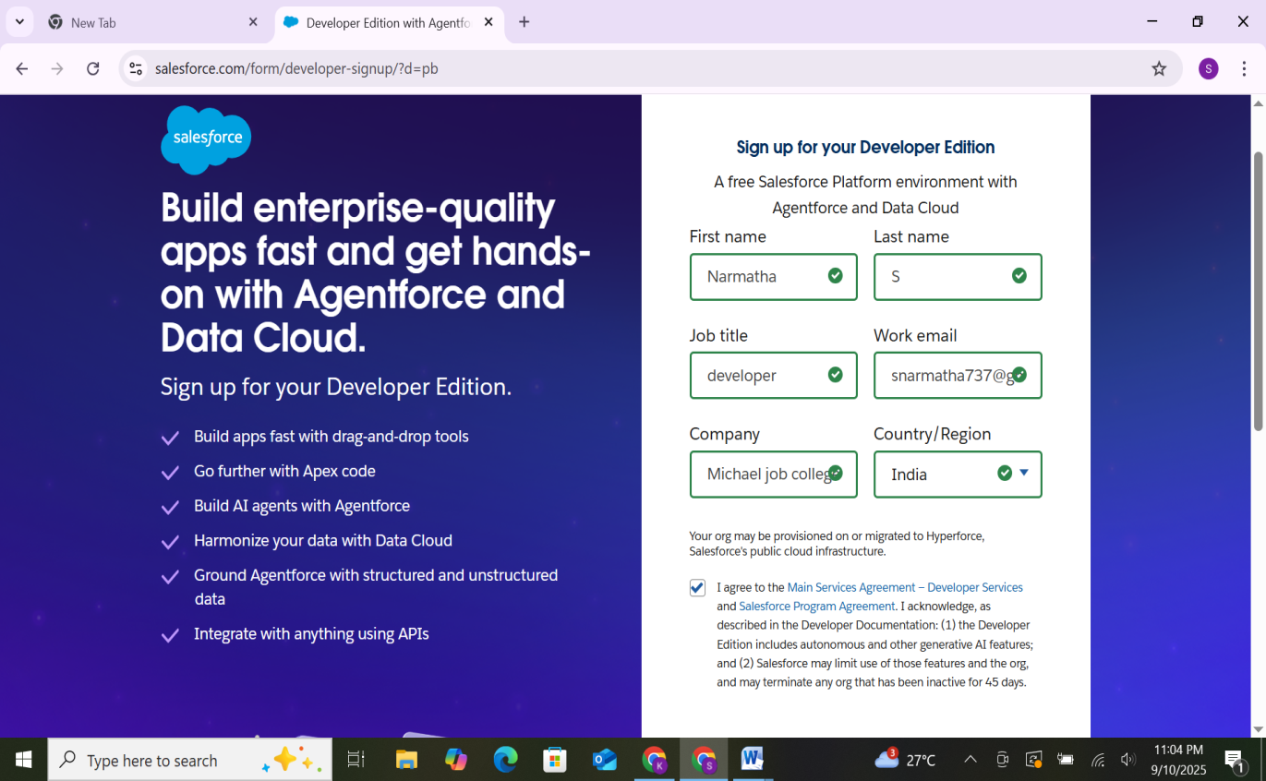

* Created custom objects: Supplier, Product, Purchase Order, Transaction.

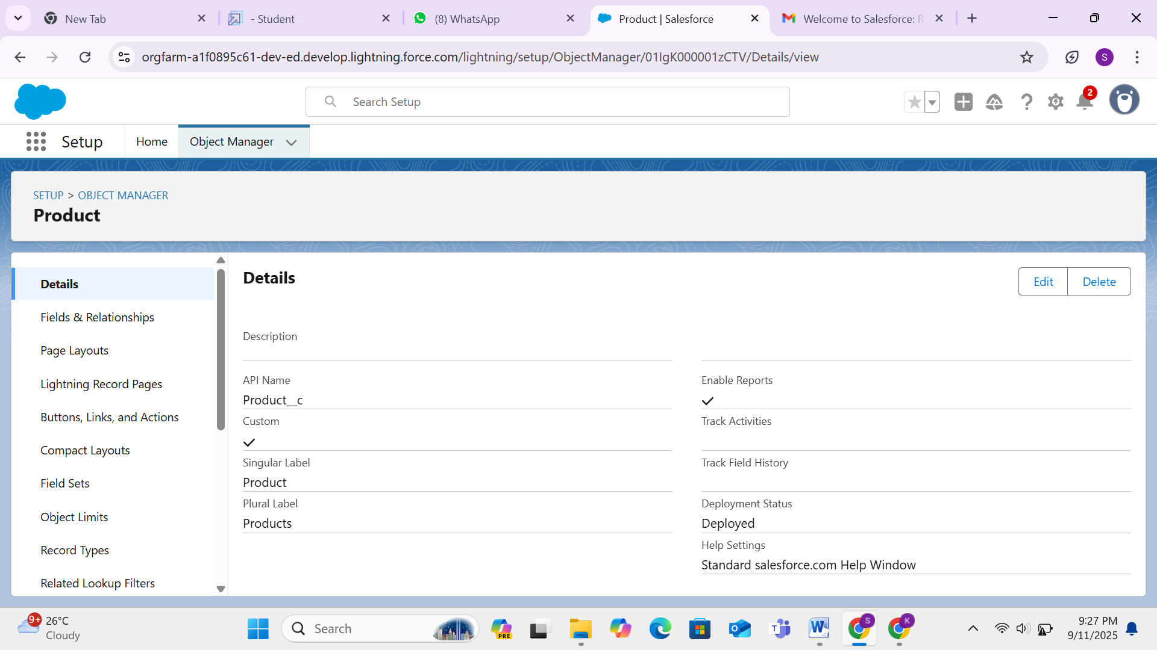

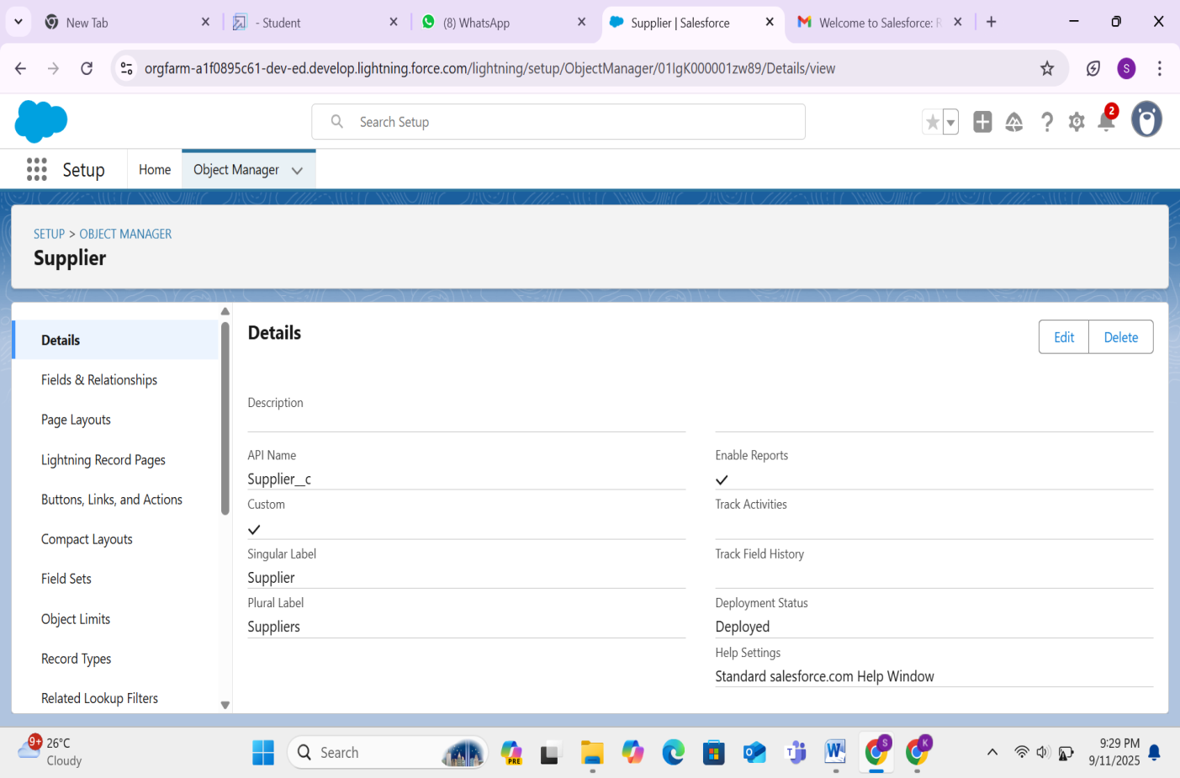

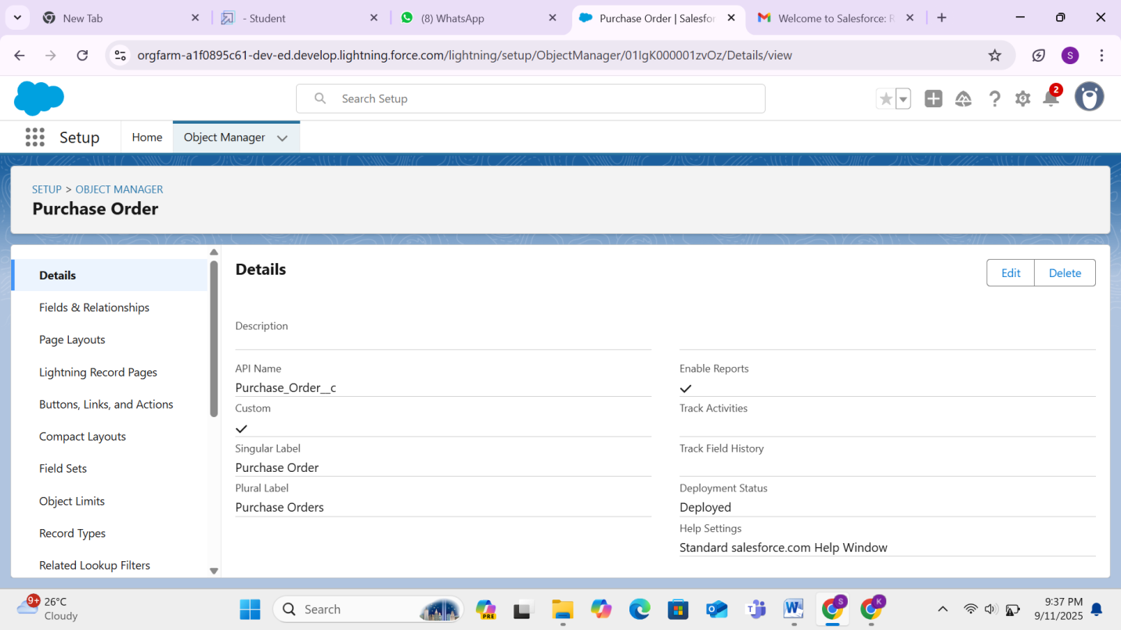

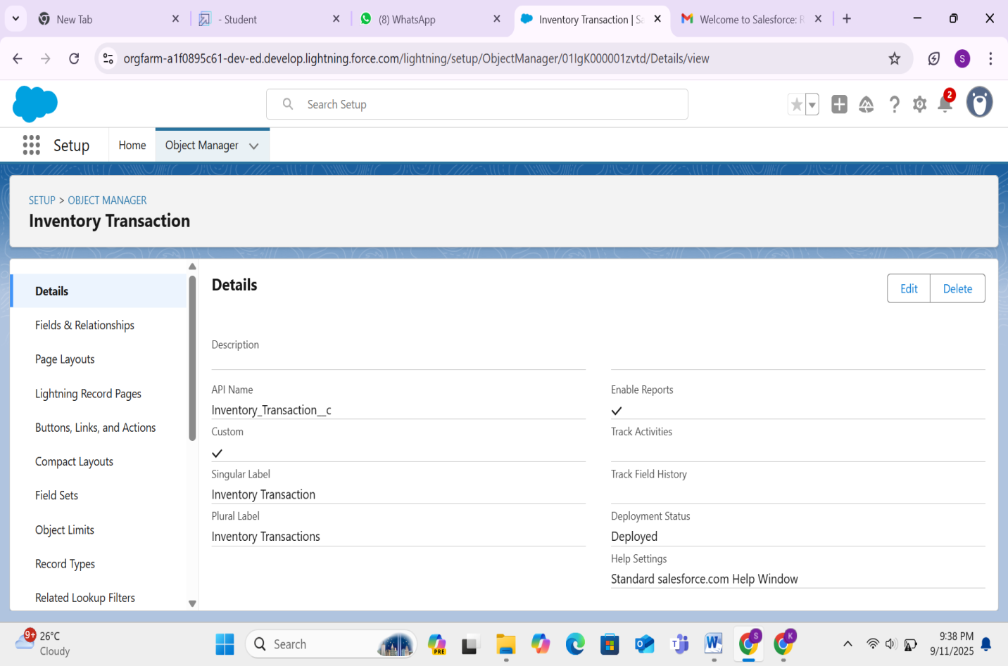

* Created tabs for all objects for easy navigation.

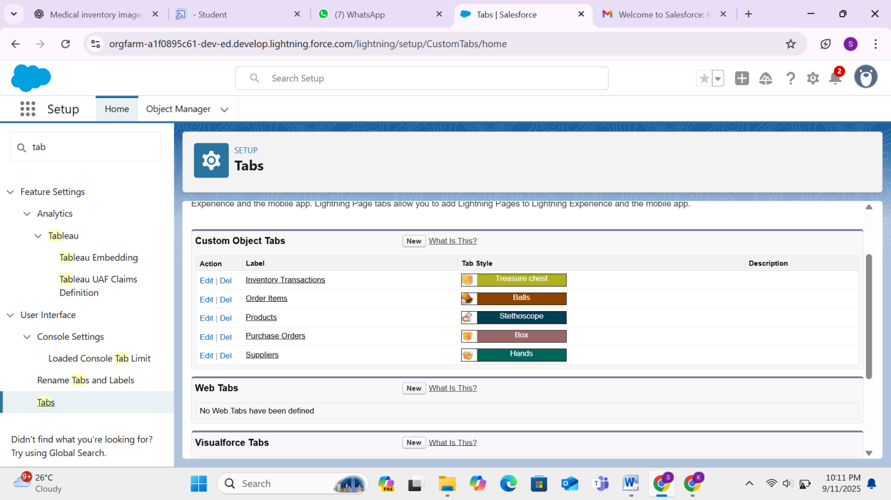

* Built a Lightning App including Supplier, Product, Purchase Order, and Transaction tabs.

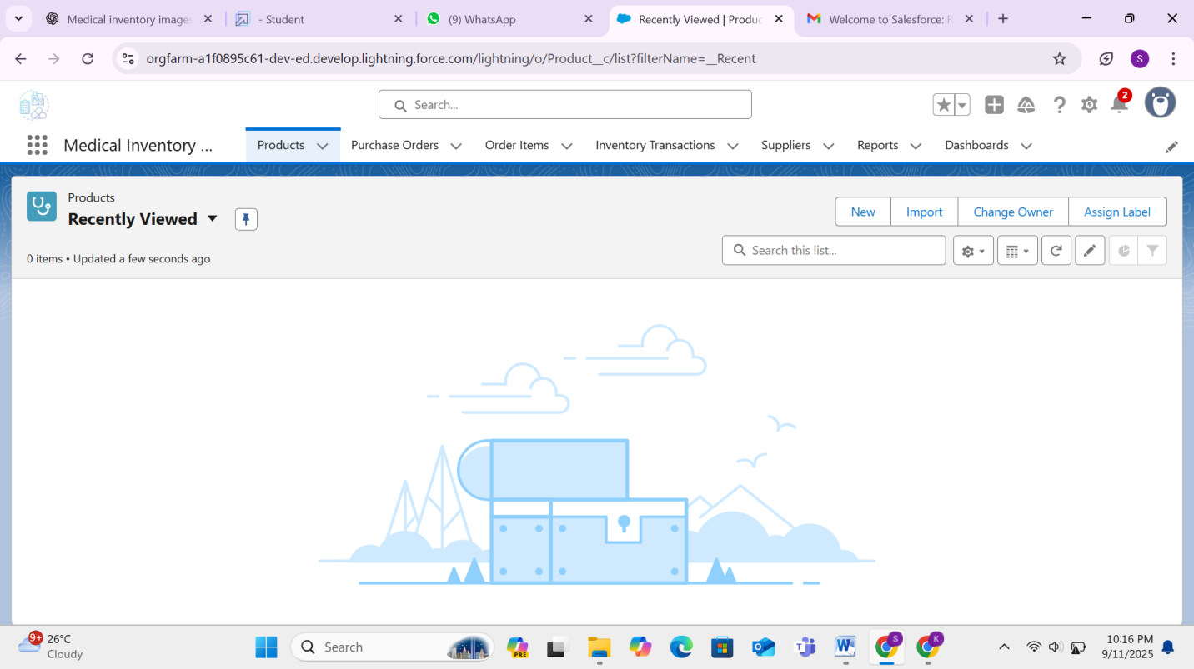

* Added custom fields to objects.

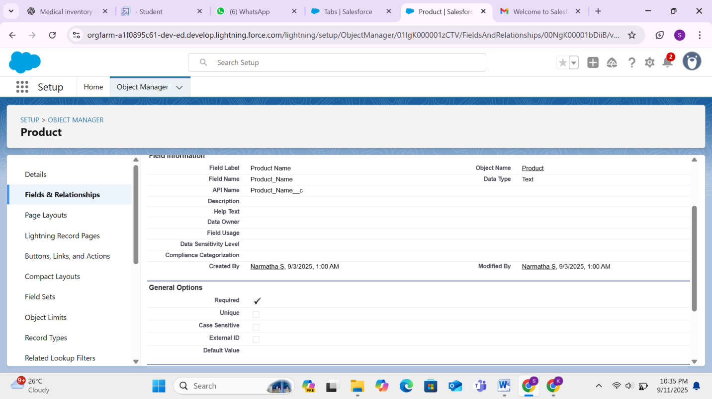

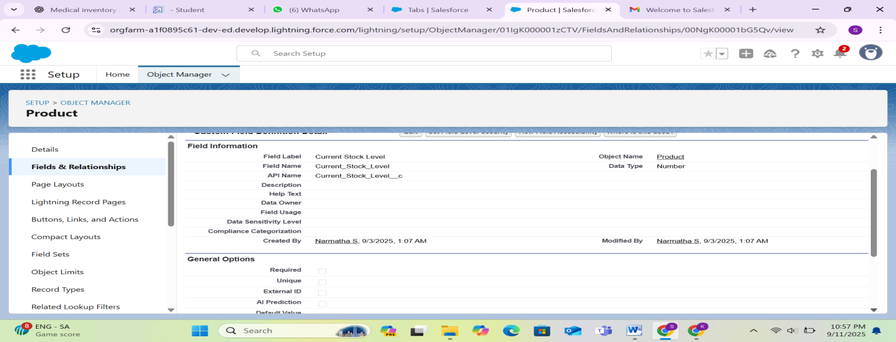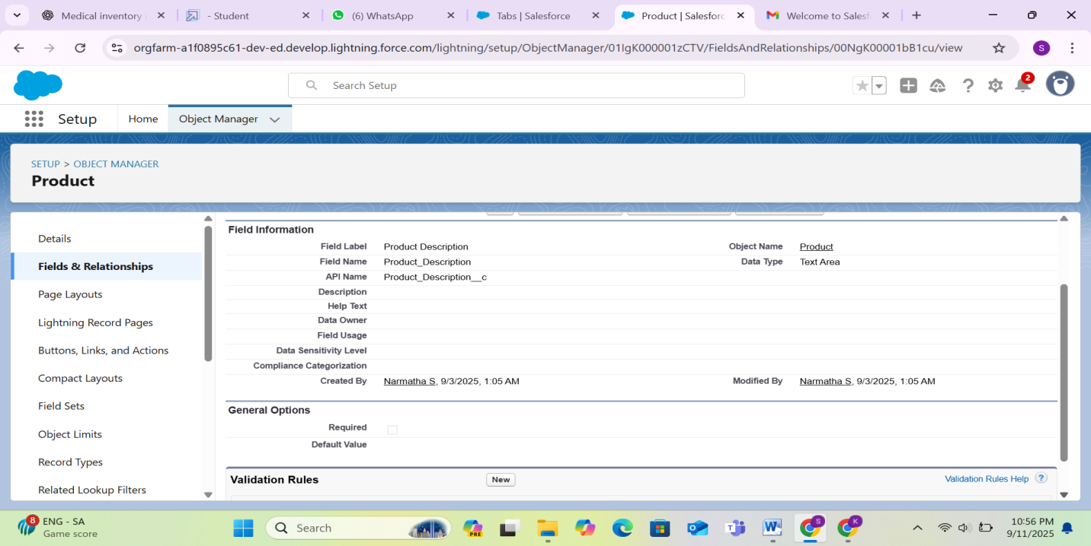

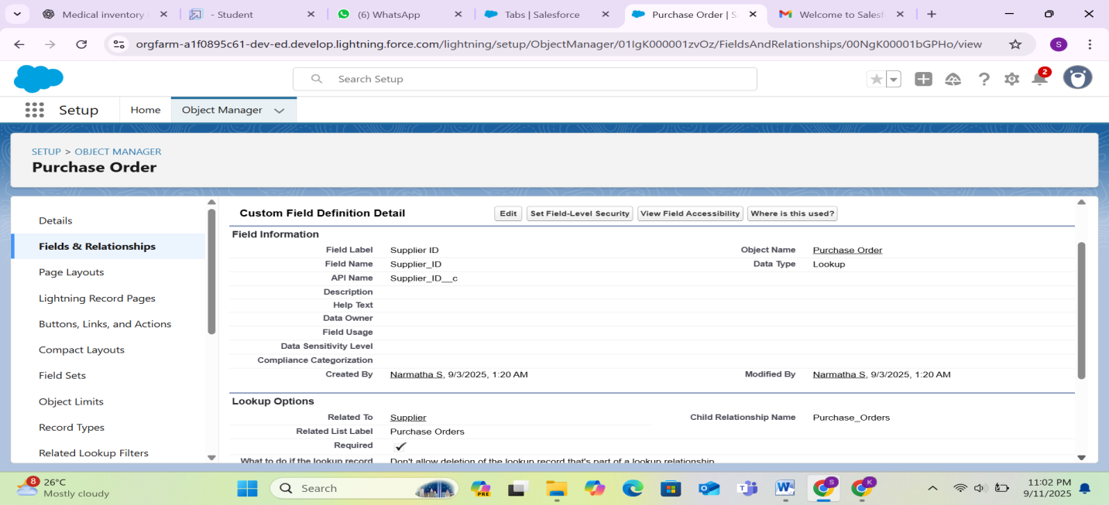

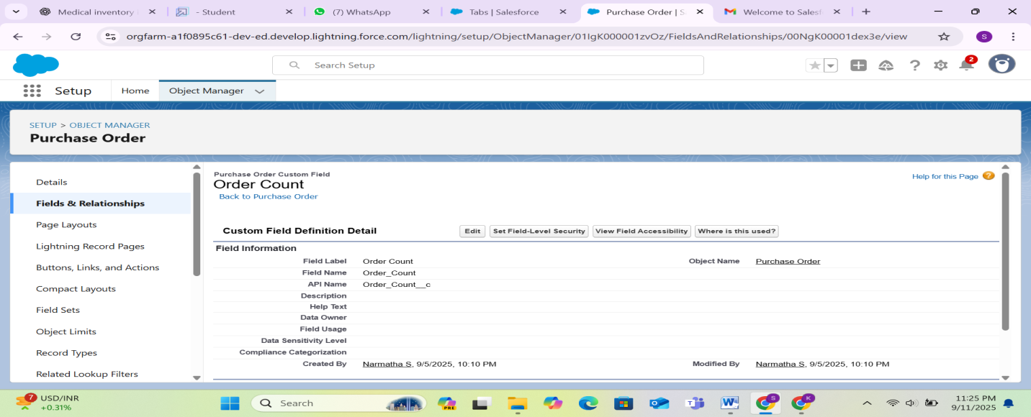

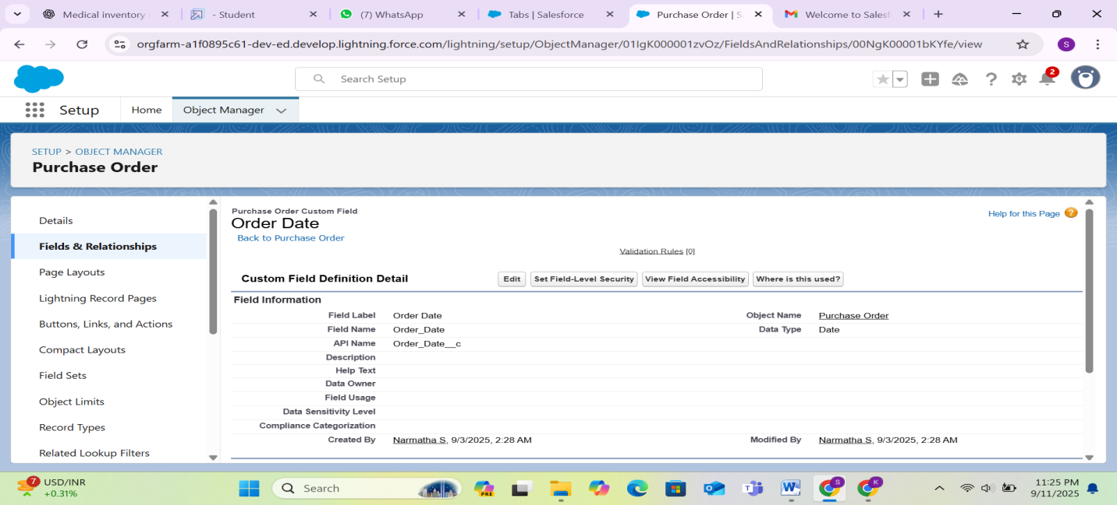

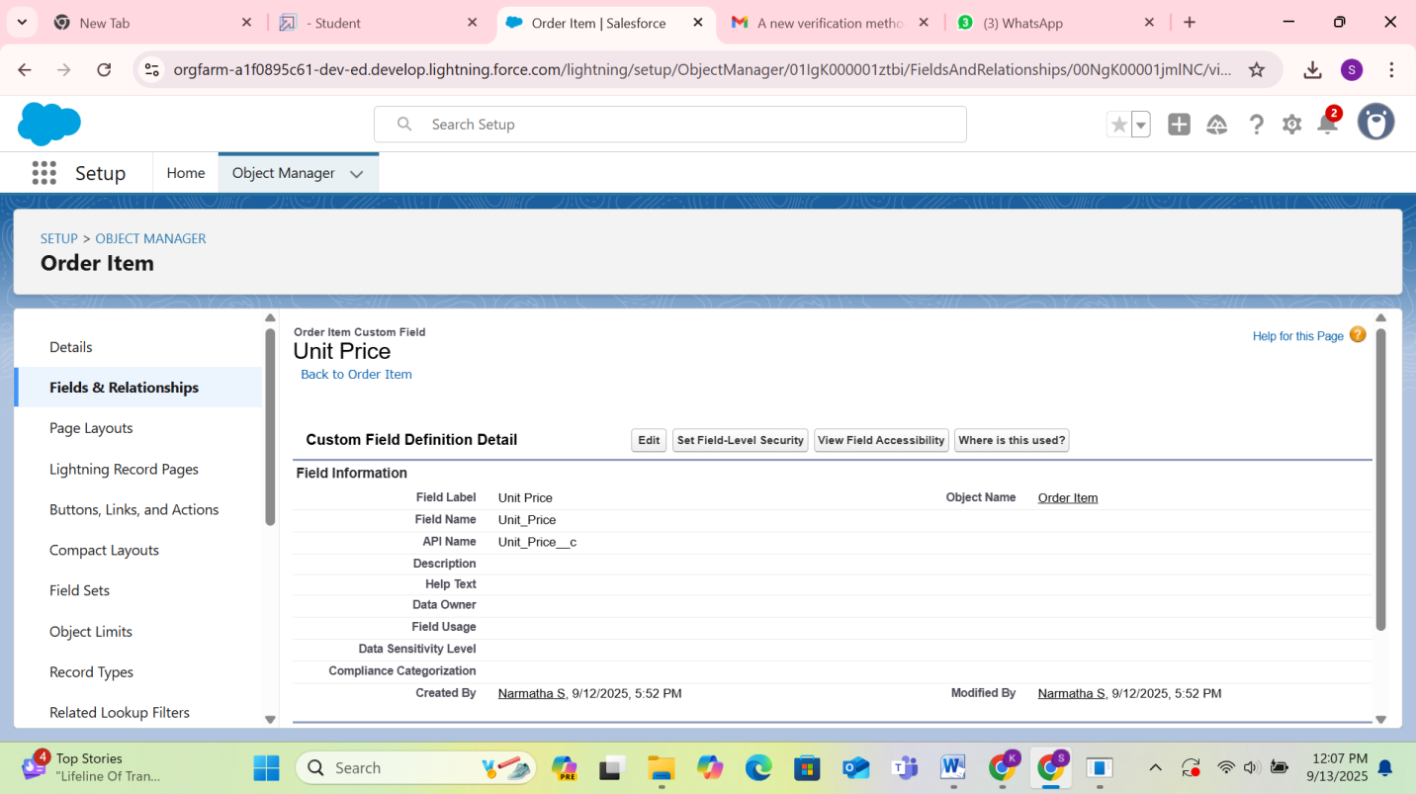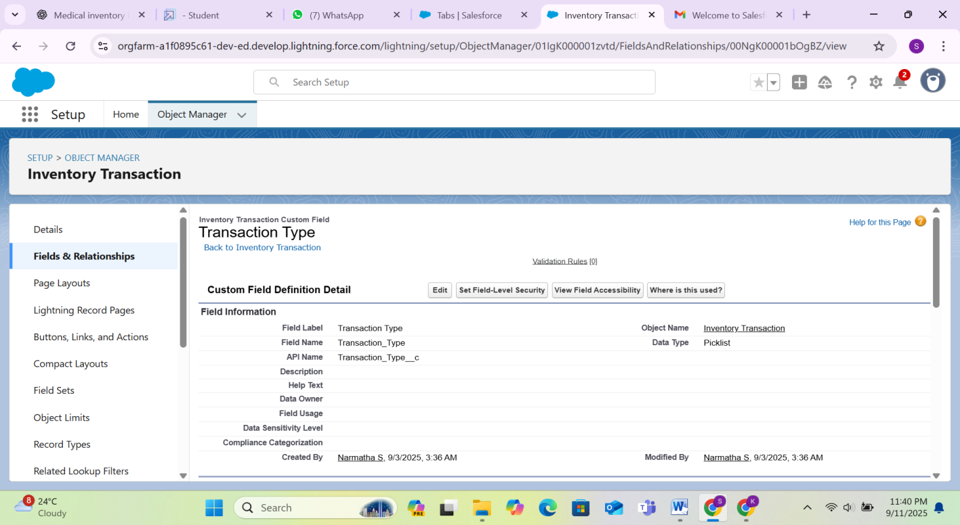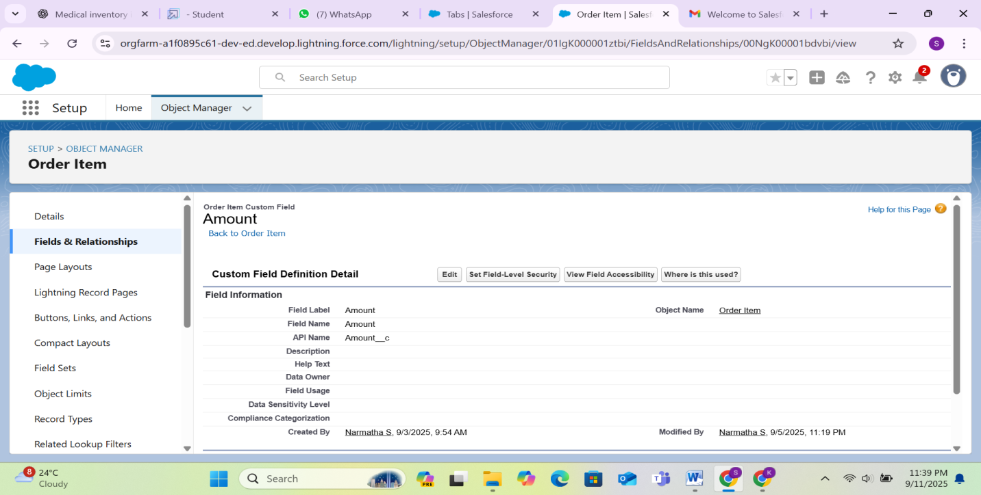

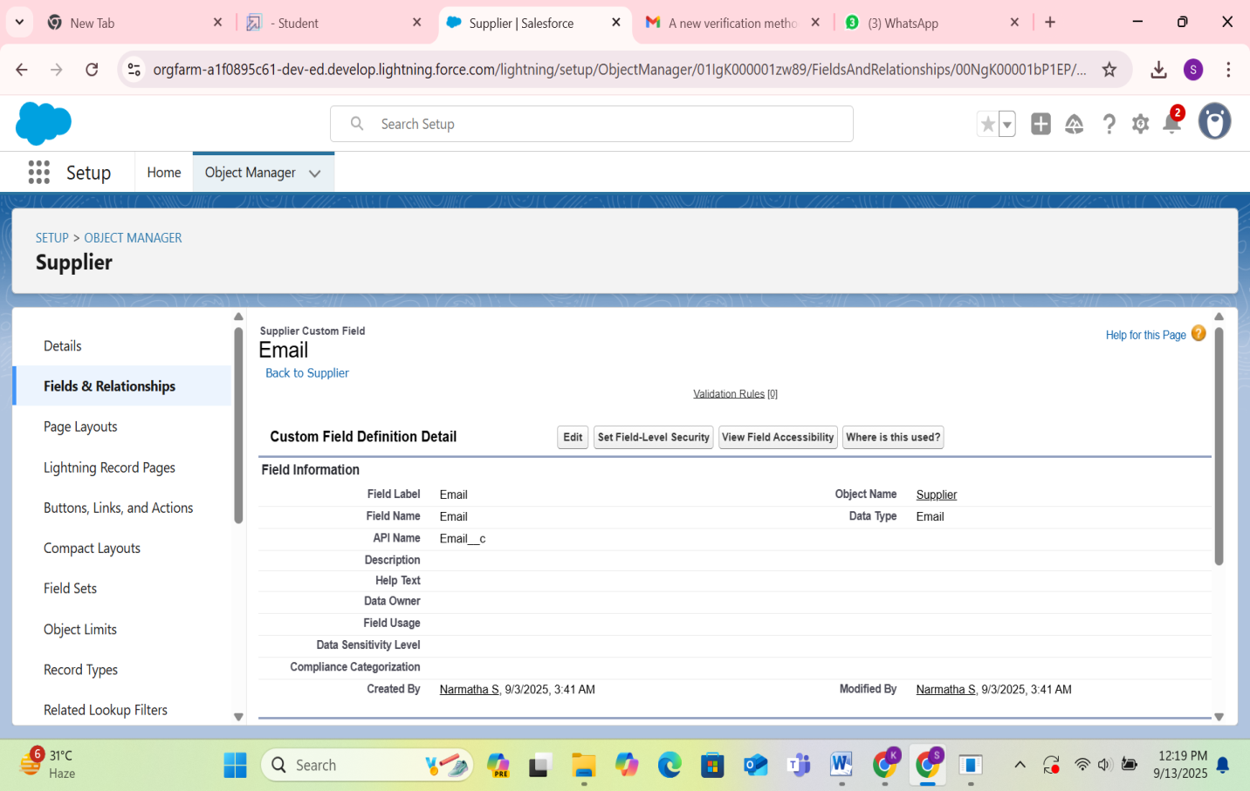

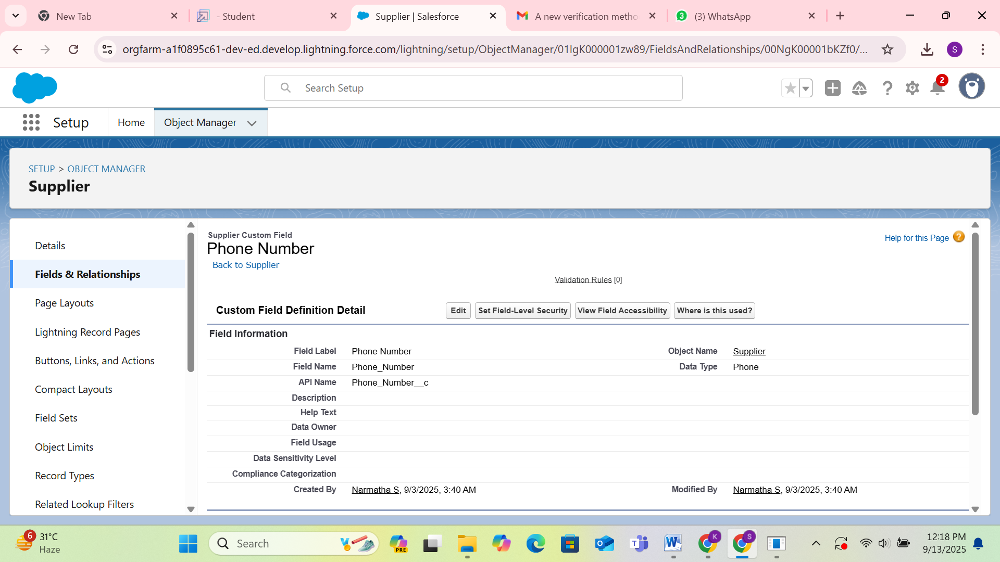

## Updating of Page Layouts

* Customized page layouts to display relevant fields and sections.

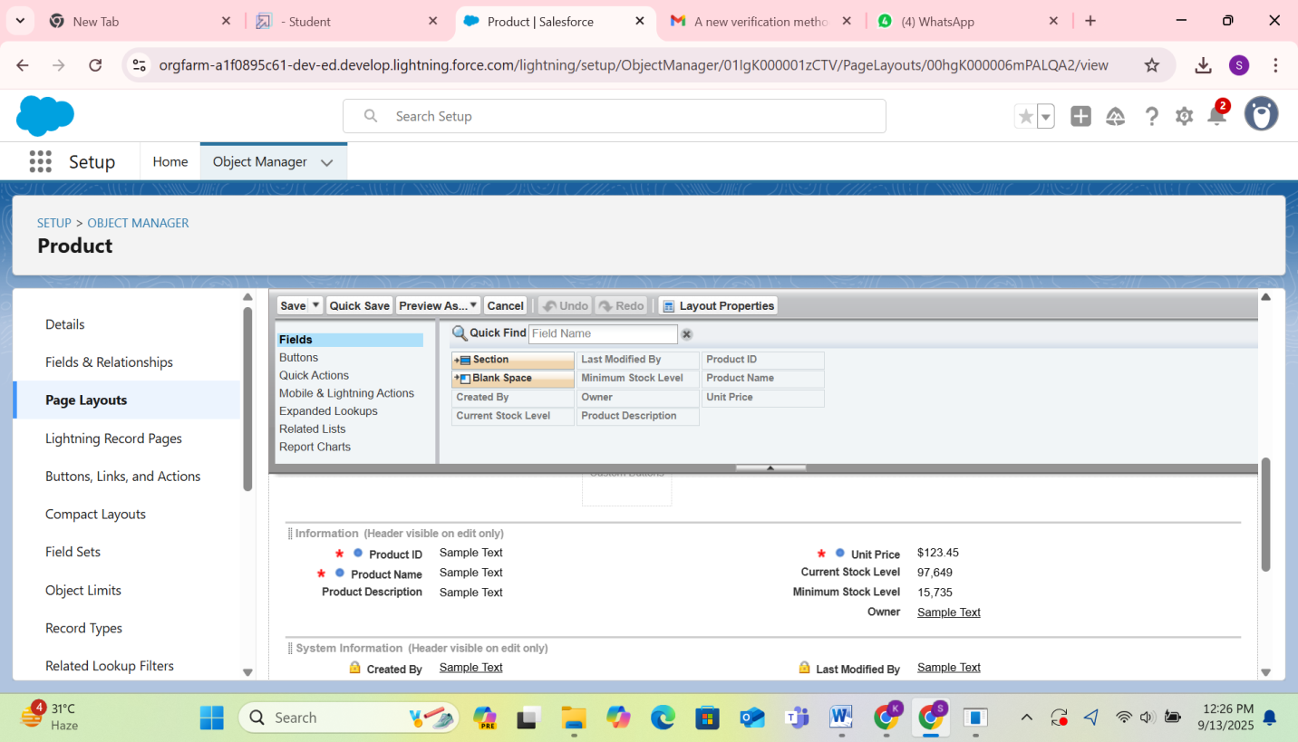

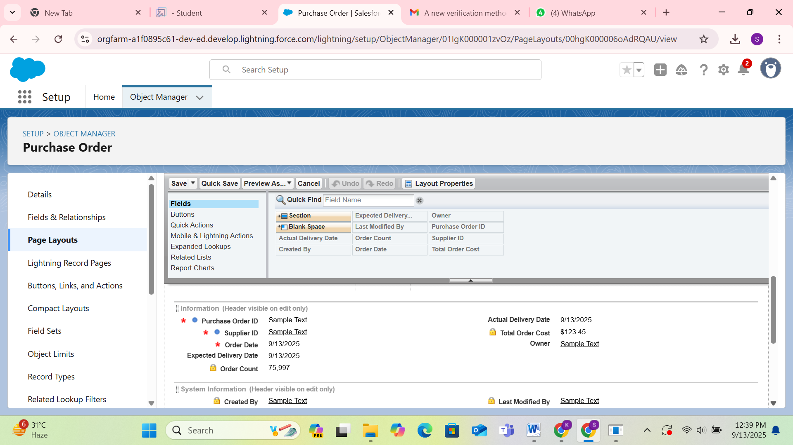

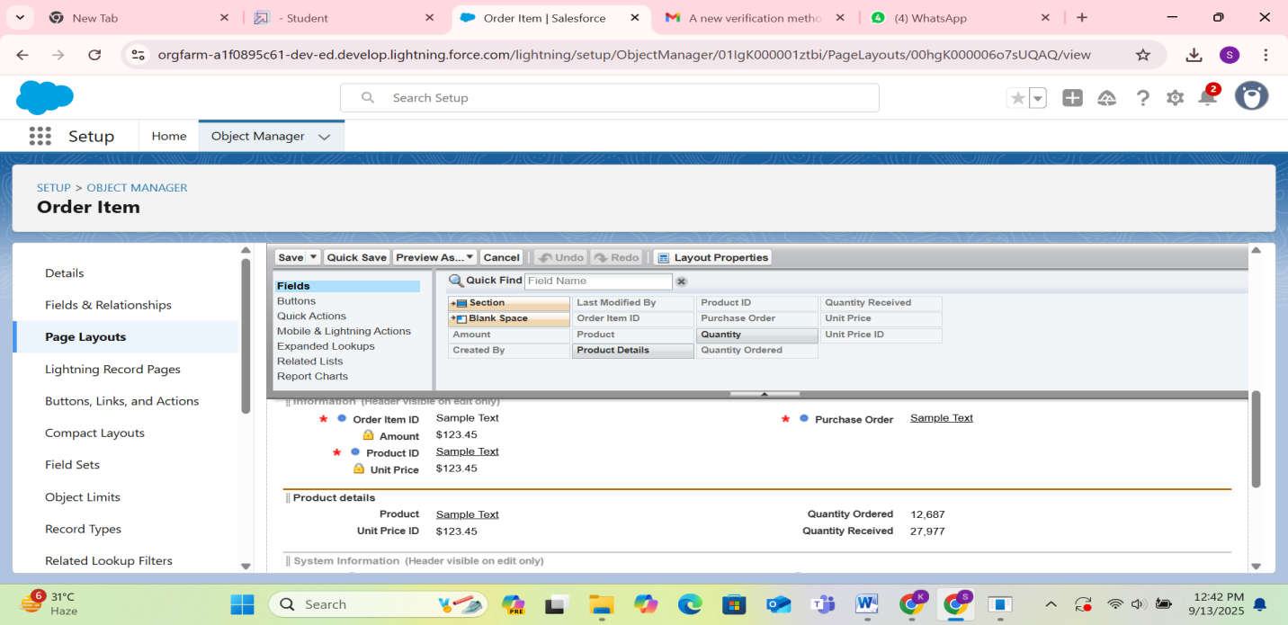

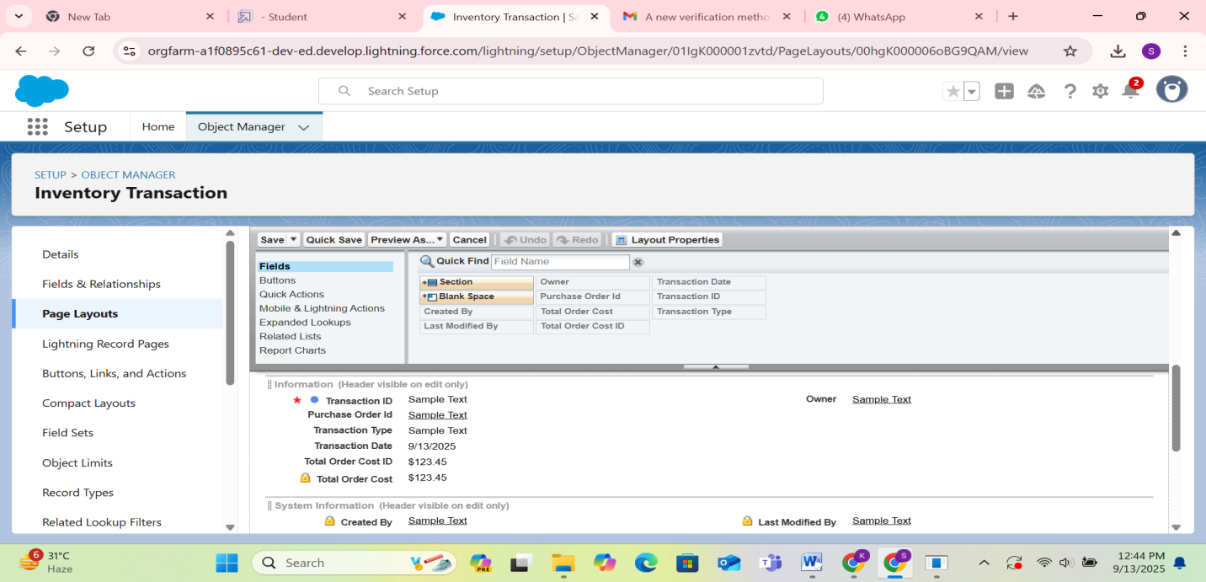

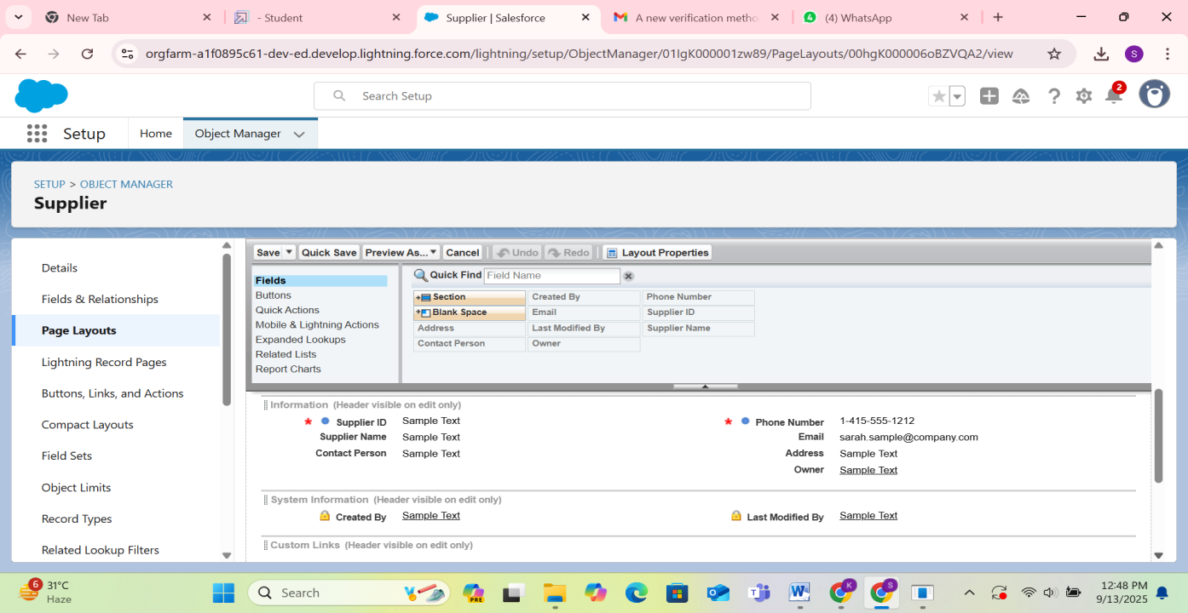

* Configured compact layouts for quick record preview.

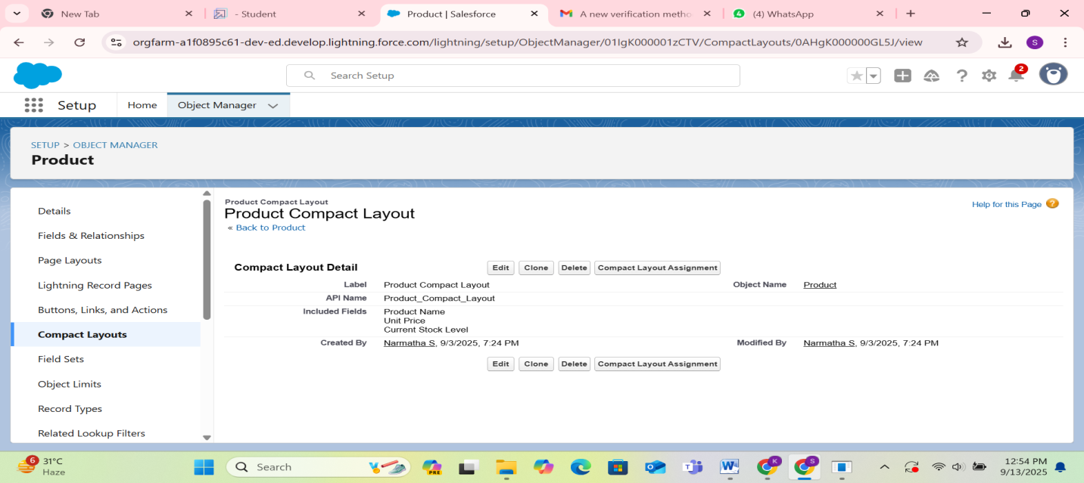

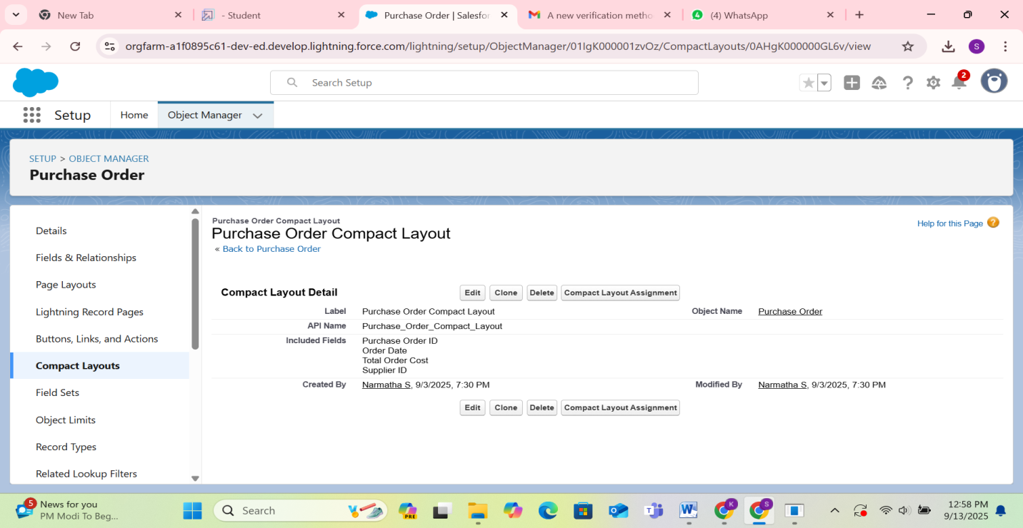

## Validation Rules

* Prevented expired products from being added.
* Mandatory supplier details before creating purchase orders.

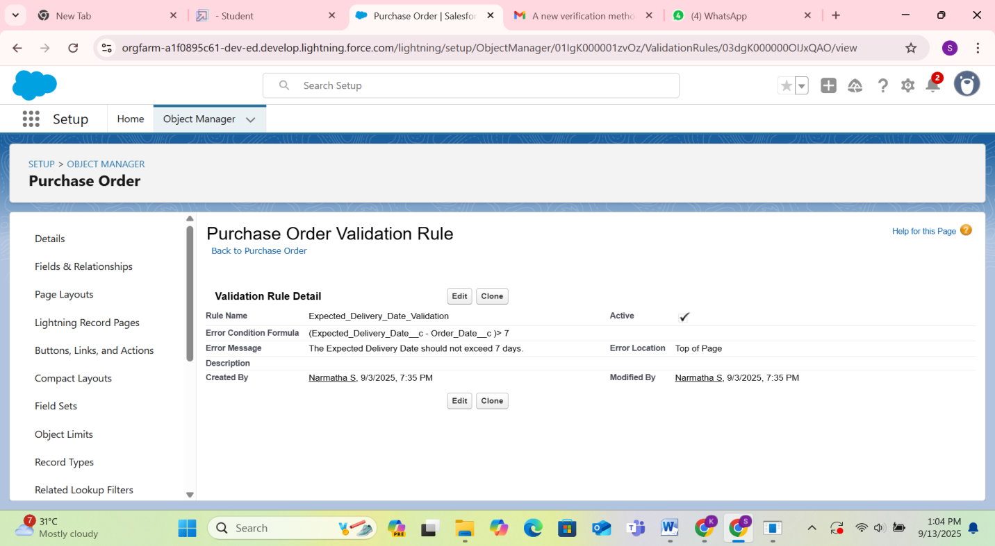

## Profiles

* Configured profiles for user access and permissions.

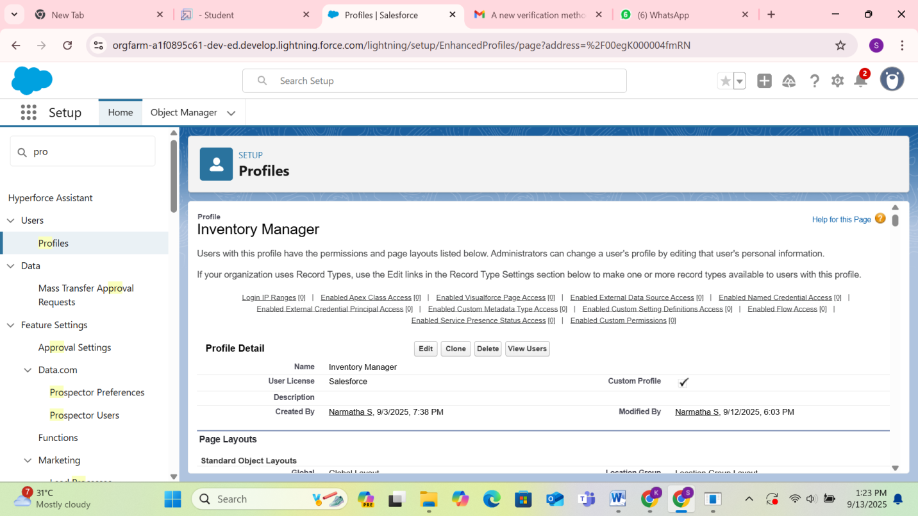

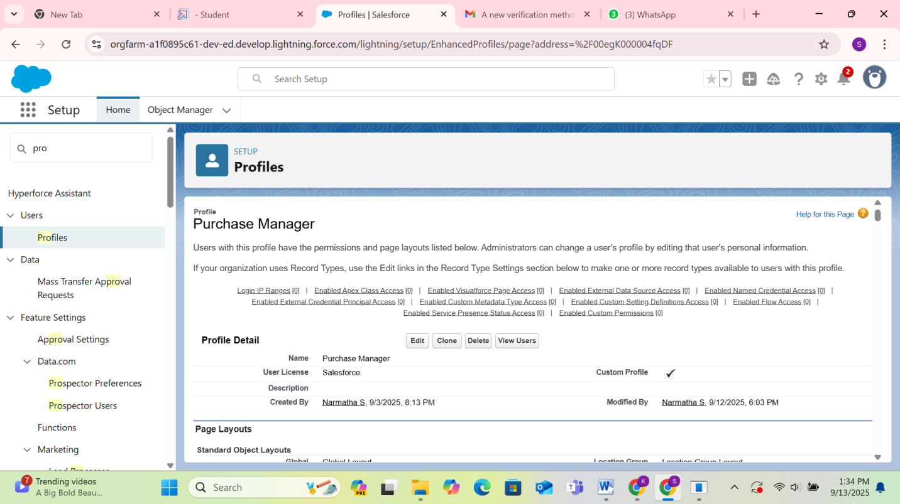

## Roles

* Created roles to define data visibility across users.

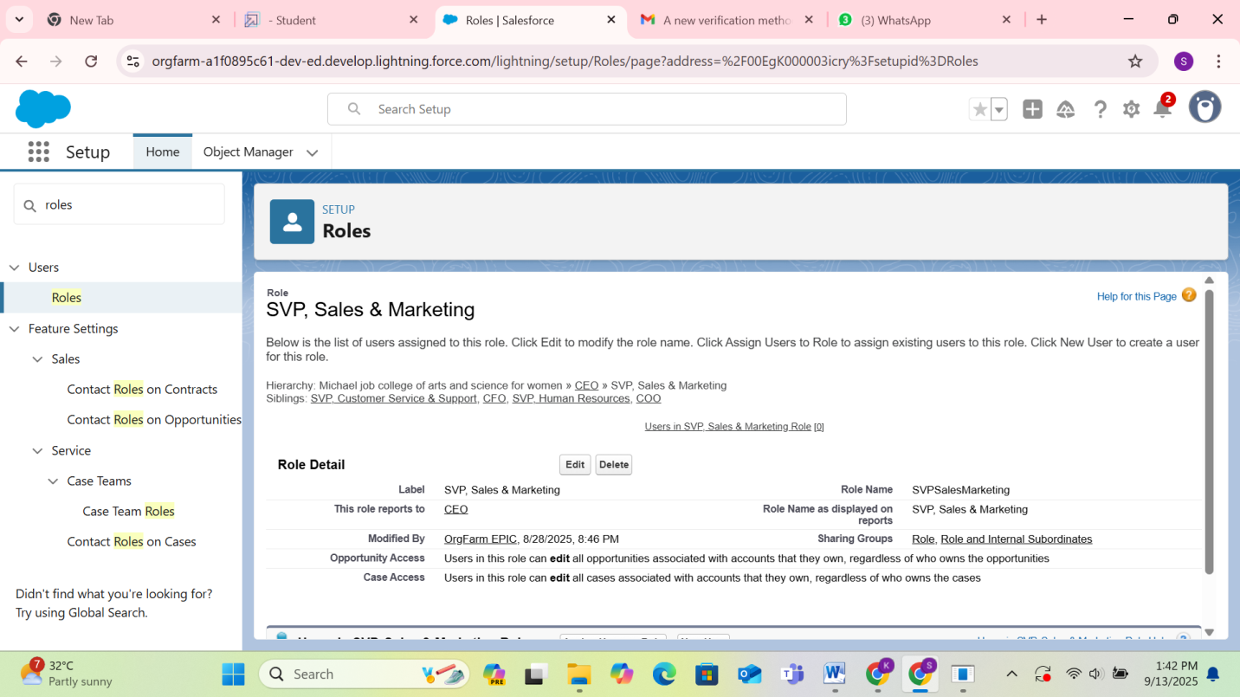

## Permission Sets

* Created permission sets to grant additional access.

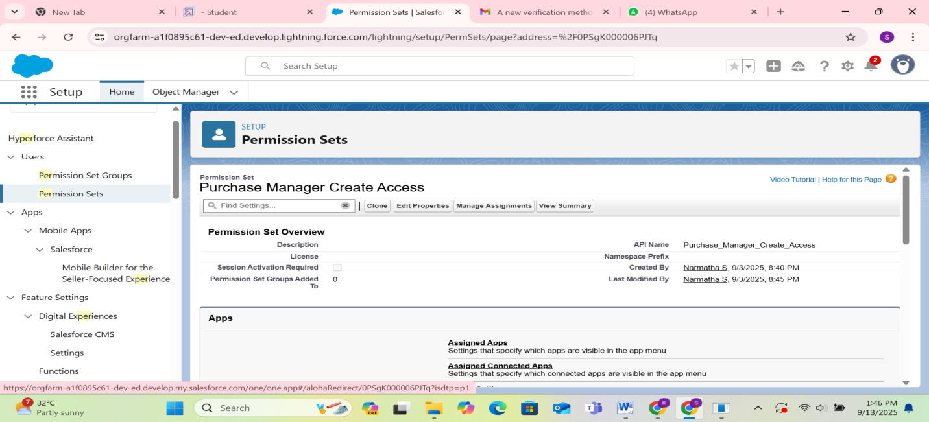

## Flows

* Stock Reorder Flow → Alerts when stock is low.
* Expiry Alert Flow → Notifies when products near expiry.

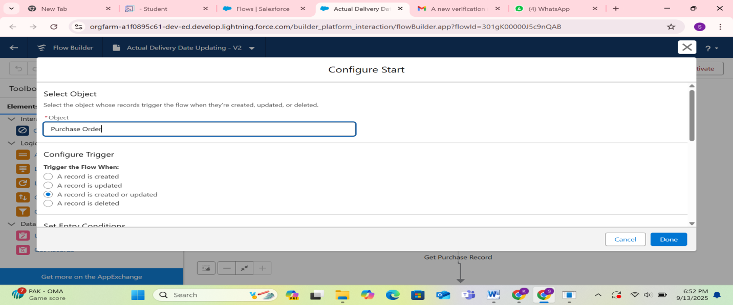

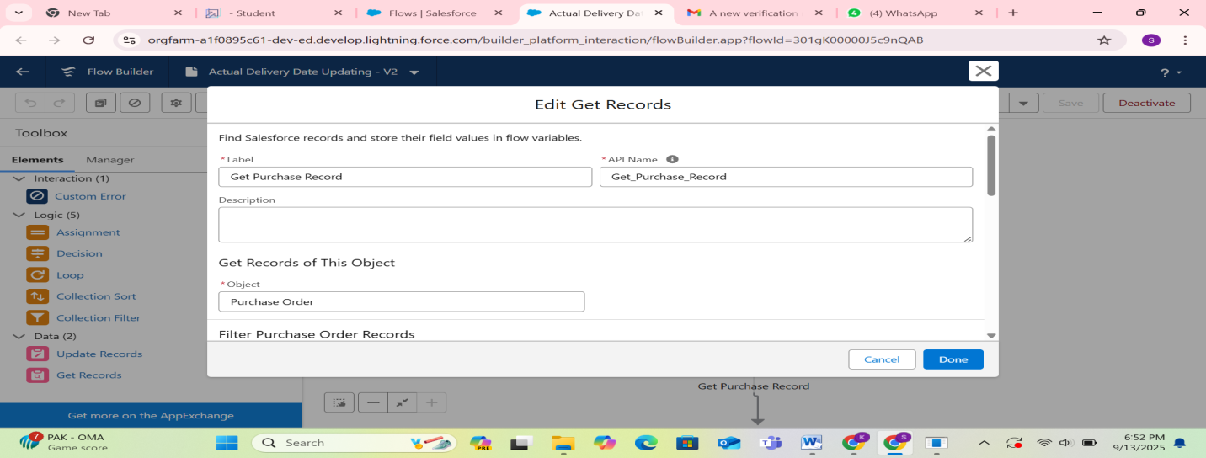

## Triggers

* Trigger to prevent duplicate products.
* Trigger to auto-update stock after Purchase order approval.

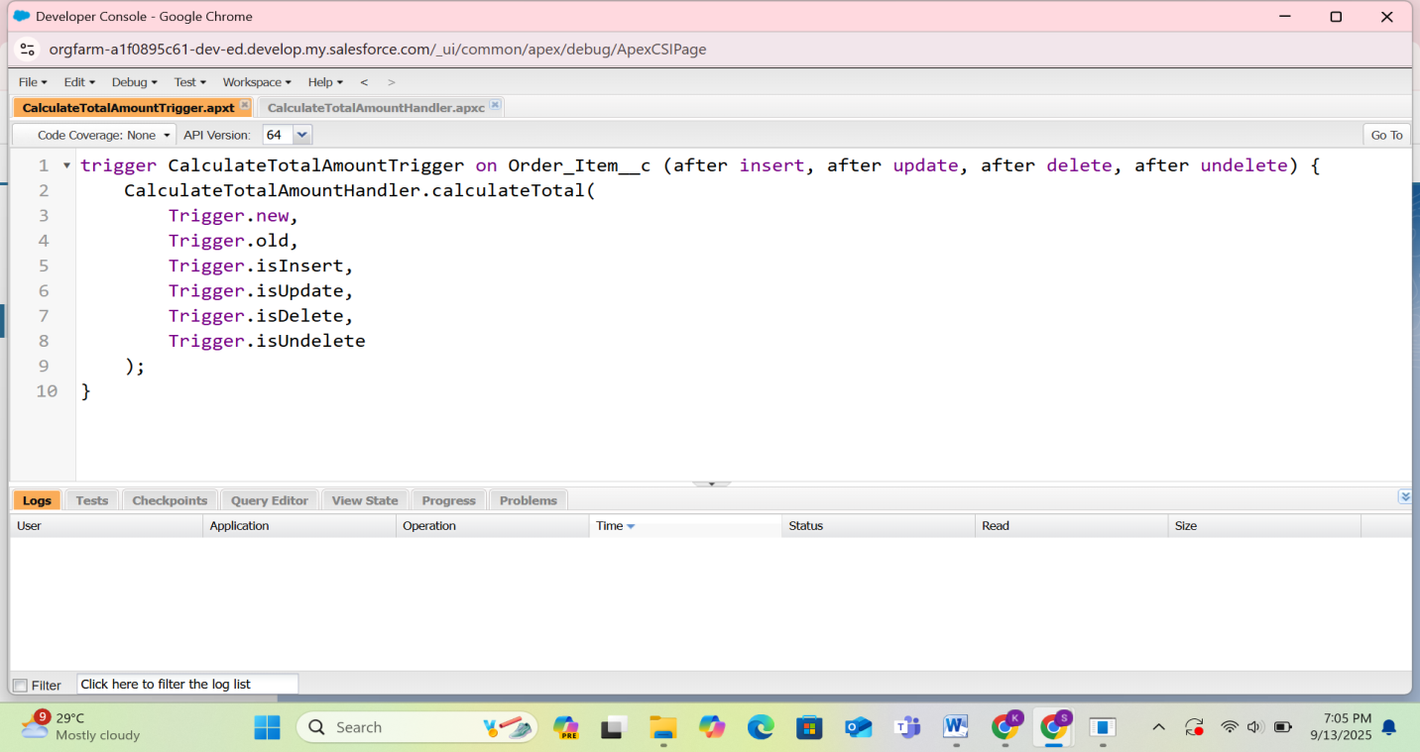

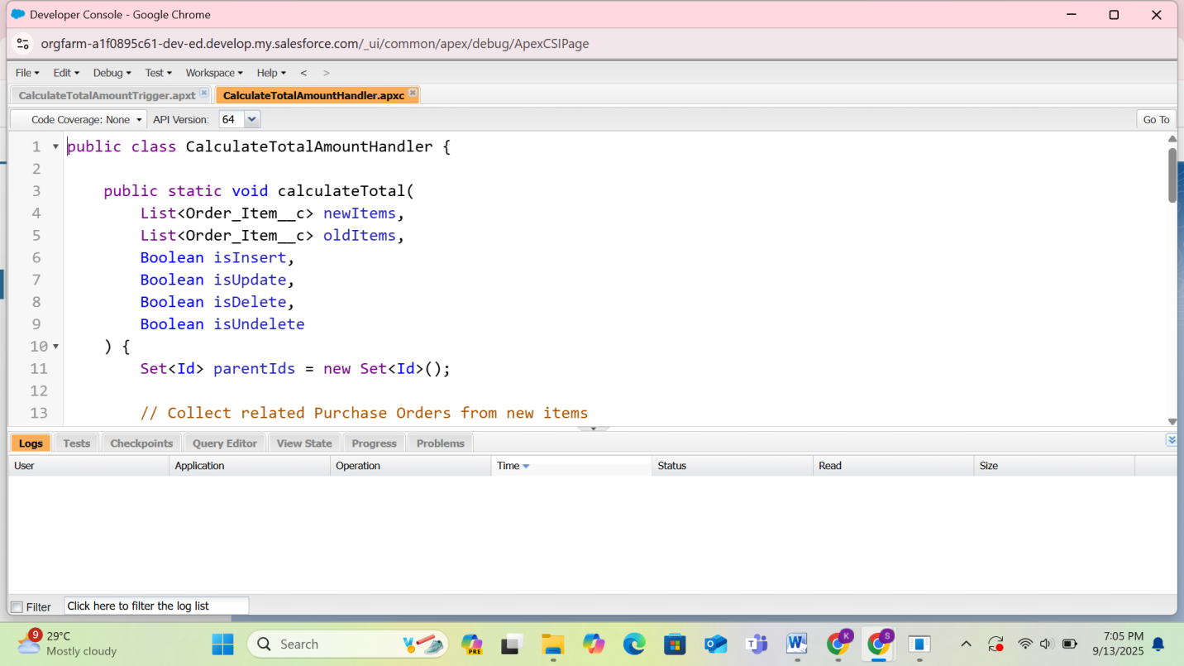

## Reports

* Generated reports for supplier performance, stock status, and purchase orders.

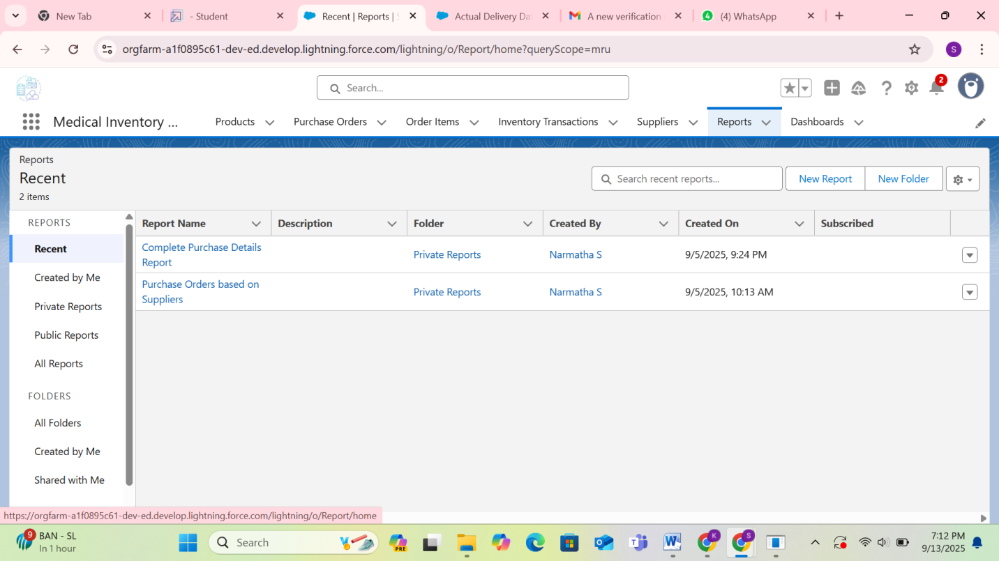

## Dashboards

* Created dashboards to visualize stock levels, supplier performance, and transactions.

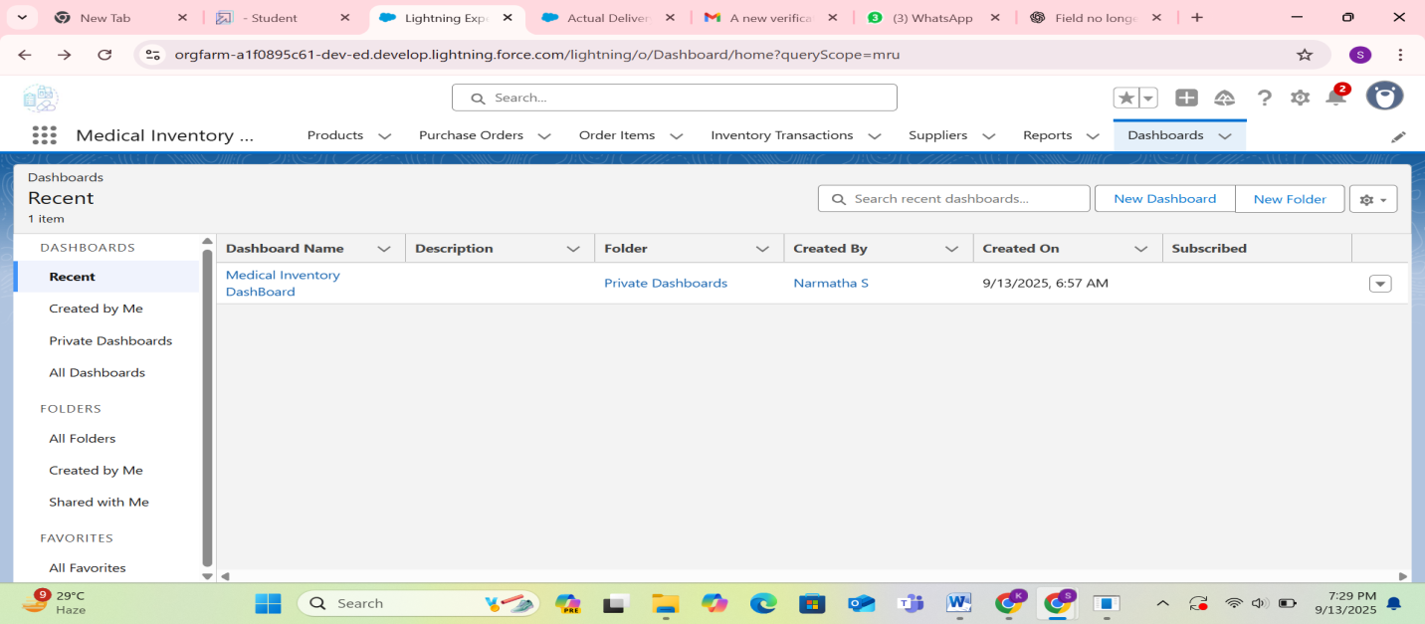

# FUNCTIONAL AND PERFORMANCE TESTING

* Tested validation rules by attempting invalid inputs.
* Verified trigger functionality with duplicate product entries.
* Confirmed flows run automatically on stock and expiry events.
* Validated approval processes with email notifications.

# RESULTS

* Tabs displayed for Supplier, Product, Purchase Order, Transaction.
* Email alerts for approvals, rejections, and expiry reminders.
* Trigger error messages shown on duplicate entries.
* Flow executions successfully performed.

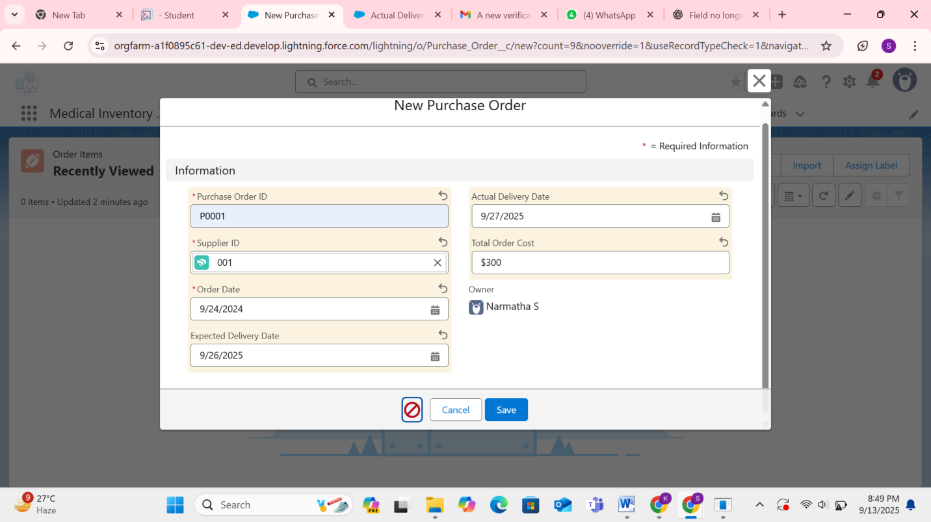

# ADVANTAGES & DISADVANTAGES

## Advantages:

* + Streamlines medical inventory processes.
  + Reduces manual errors.
  + Provides real-time alerts and reports.
  + Improves decision-making.

## Disadvantages:

* + Requires Salesforce expertise for setup.
  + Internet dependency.
  + Licensing cost for enterprise-level usage.

# CONCLUSION

The **Medical Inventory Management System** built on Salesforce effectively automates medical inventory operations. By integrating supplier management, product tracking, purchase order workflows, and automated alerts, the system improves accuracy, reduces manual effort, and supports better organizational efficiency.

# APPENDIX

## Trigger (Prevent Duplicate Products)

trigger PreventDuplicateProducts on Product__c (before insert) {

Set<String> existingProducts = new Set<String>();

for (Product__c prod : [SELECT Name FROM Product__c]) {

existingProducts.add(prod.Name);

}

for (Product__c newProd : Trigger.new) {

if (existingProducts.contains(newProd.Name)) {

newProd.addError('This product already exists in inventory.');

}

}

}

## ****Scheduler (Monthly Inventory Report)****

global class MonthlyInventoryReport implements Schedulable {

global void execute(SchedulableContext sc) {

sendInventoryReport();

}

public static void sendInventoryReport() {

List<Product__c> products = [SELECT Name, Quantity__c, Expiry_Date__c FROM Product__c];

String report = 'Monthly Inventory Report:\n\n';

for (Product__c p : products) {

report += 'Product: ' + p.Name + ', Quantity: ' + p.Quantity__c + ', Expiry: ' + p.Expiry_Date__c + '\n';

}

Messaging.SingleEmailMessage email = new Messaging.SingleEmailMessage();

email.setToAddresses(new String[]{'admin@hospital.com'});

email.setSubject('Monthly Inventory Report');

email.setPlainTextBody(report);

Messaging.sendEmail(new Messaging.SingleEmailMessage[]{email});

}

}